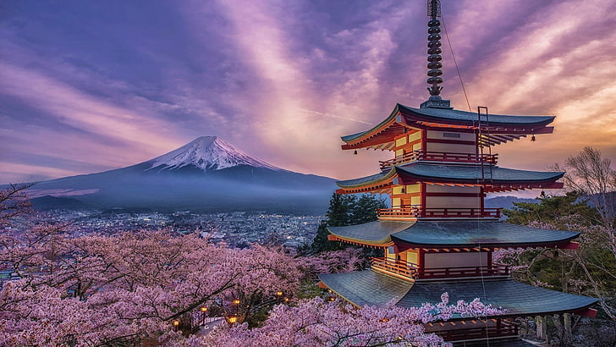dfgdd

DISCOVER THE LAND OF THE RISING SUN AND ITS WONDERS

TRAVEL TO JAPAN

Japan a harmonious Fusion of tradition and innovation

Visiting Japan promises a vibrant blend of tradition and innovation, captivating landscapes, and rich cultural experiences. Expect bustling metropolises like Tokyo, where neon-lit streets converge with serene temples and tranquil gardens. Immerse yourself in the serenity of Kyoto's ancient temples and traditional tea ceremonies. Savour culinary delights, from sushi and ramen to delicate wagashi sweets. Experience the efficiency of Japan's high-speed trains juxtaposed with the tranquility of rural countryside. Encounter the warmth and hospitality of the Japanese people, steeped in a deep respect for tradition and harmony. Whether exploring modern skyscrapers or historic castles, Japan offers an unforgettable journey blending the past and the present in perfect harmony

**Cost Considerations**

**Places to Stay**

1. **Luxury Accommodations:** Pamper yourself in luxurious hotels like the Park Hyatt Tokyo or The Peninsula Tokyo, offering unparalleled comfort and service.
2. **Budget-Friendly Options:** Explore affordable options such as capsule hotels, guesthouses, or Airbnb rentals in vibrant neighbourhood’s like Ikebukuro or Ueno.
3. **Traditional Ryokans:** Experience Japanese hospitality first-hand by staying in a traditional ryokan, where you can sleep on tatami mats, enjoy kaiseki cuisine, and soak in soothing hot springs.
4. **Transportation:** Budget for transportation costs, including subway and train fares. Consider purchasing a prepaid transportation card like Suica or Pasmo for convenience.
5. **Accommodation:** Prices vary depending on the type of accommodation and location. Book in advance for the best deals, especially during peak seasons.
6. **Dining:** Enjoy a range of dining options to suit every budget, from affordable street food to high-end restaurants. Set aside a budget for culinary experiences you don't want to miss.
7. **Activities:** Many attractions in Tokyo offer free or discounted admission for children, students, and seniors. Research ticket prices and consider purchasing city passes for savings on multiple attractions.
8. **Explore Historic Temples:** Dive into Tokyo's rich cultural heritage by visiting iconic temples such as Senso-ji in Asakusa or Meiji Shrine in Shibuya.
9. **Shop ‘til You Drop:** Indulge in a shopping spree at famous districts like Ginza for luxury brands, Harajuku for quirky fashion, and Akihabara for electronics and anime.
10. **Enjoy Stunning Views:** Ascend Tokyo Sky tree or Tokyo Tower for panoramic views of the cityscape, or relax in the tranquil surroundings of Shinjuku Groen National Garden.
11. **Culinary Adventures:** Delight your taste buds with a myriad of culinary delights, from savoury sushi and sashimi to steaming bowls of ramen and delectable street food in bustling districts like Shinjuku and Shibuya.

Safari Adventures Travel Agency: 456 Nelson Mandela Avenue, Johannesburg, Gauteng 2001, South Africa

Email: [info@safariadventures.co.za](mailto:info@safariadventures.co.za)

Website: [www.safariadventures.co.za](https://www.safariadventures.co.za/)

1. Savour Local Cuisine: Sample Tokyo's diverse food scene, from Michelin-starred restaurants to humble izakaya’s serving grilled skewers and sake.
2. **Cultural Festivals:** Plan your visit during traditional festivals like cherry blossom season (hanami), summer fireworks (hanabi), or the vibrant autumn foliage (koyo).
3. **Nightlife:** Experience Tokyo's vibrant nightlife with karaoke bars, jazz clubs, and izakayas staying open until the early hours of the morning.

**Food and Culture & Activities**